**BASH SCRIPTING**

**Name: Gawate Tejas Shivaji MIS : 112103044**

**Batch : S3 Div:1**

1. **Script execution**

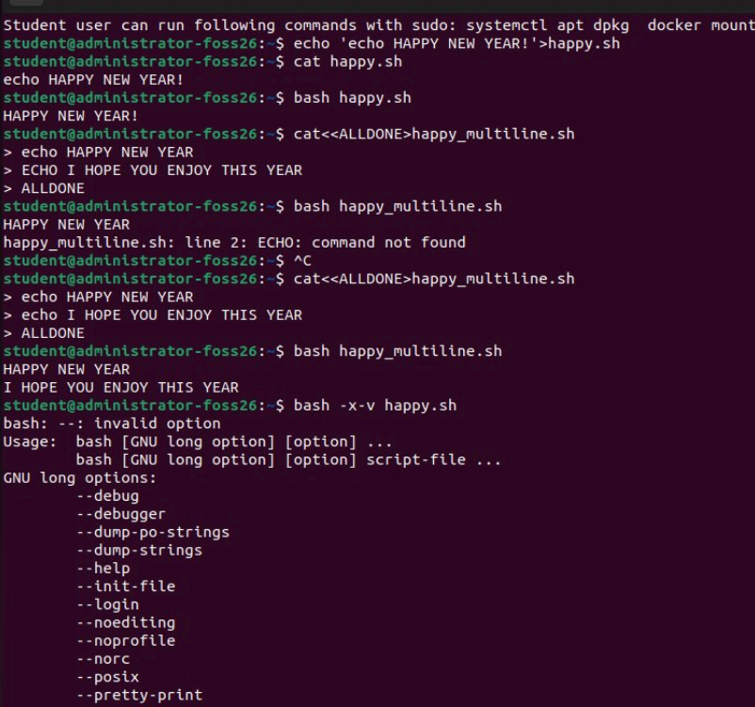

1. **Special Parameters:**

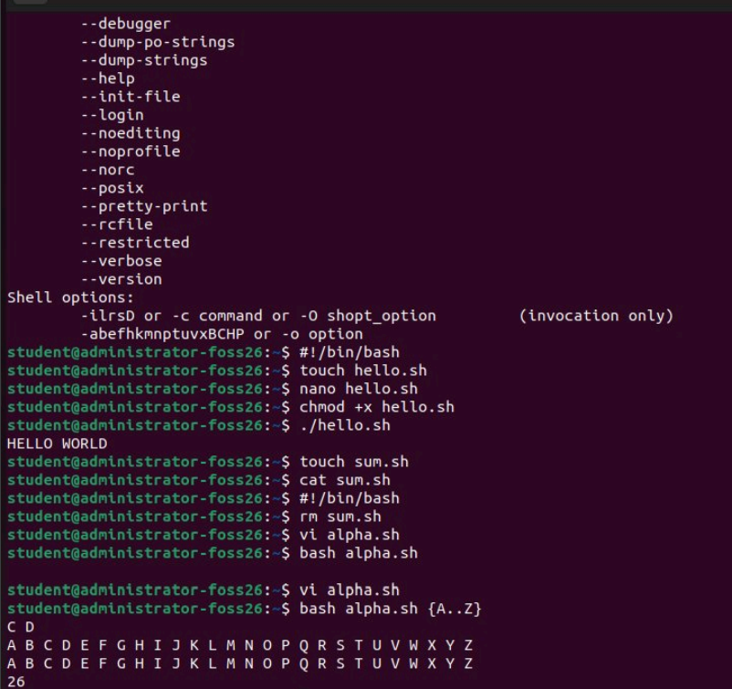

**Input commands**

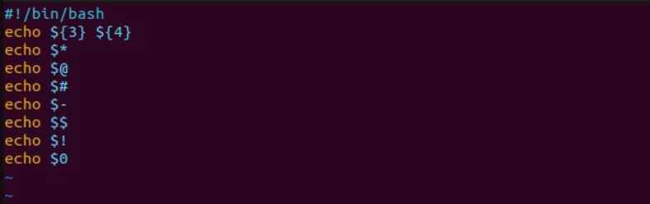

**Output** 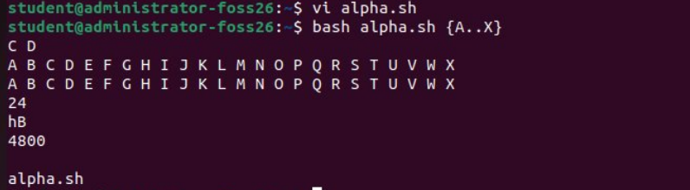

1. **Shell Expansion – arithematic:**

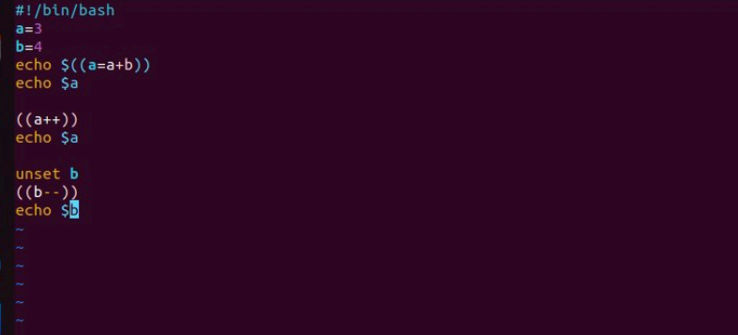

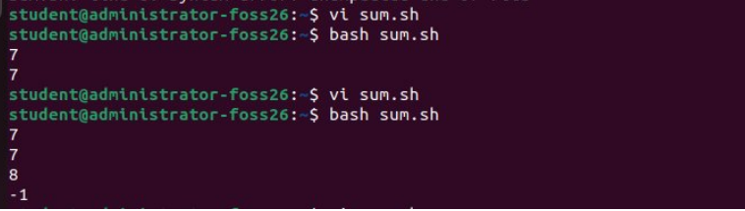

1. **Variables:**

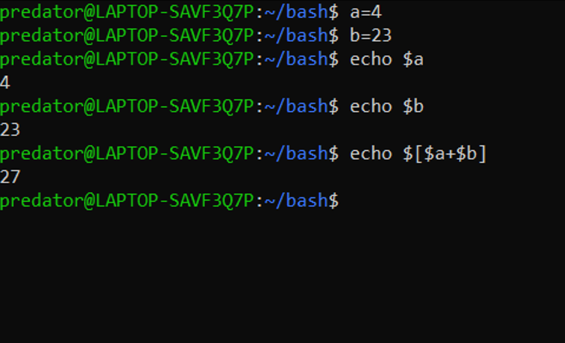

1. **Array:**

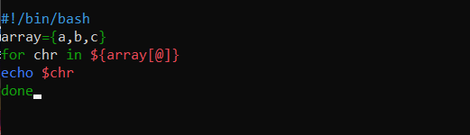

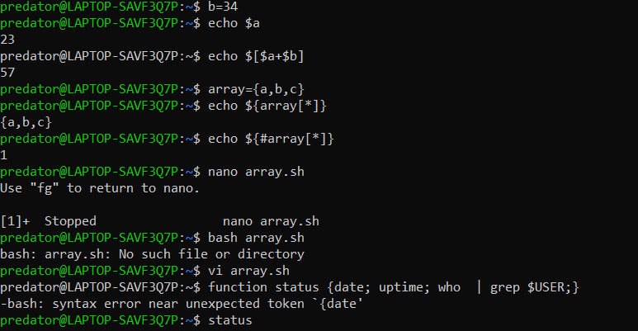

1. **Function:**

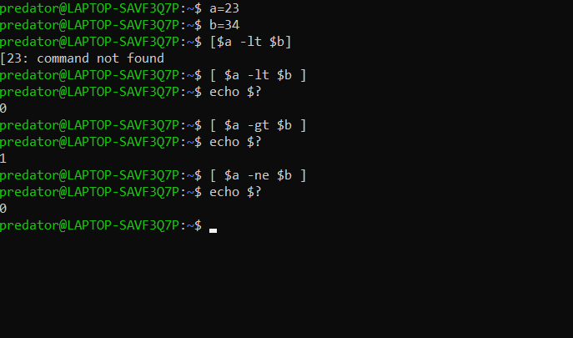

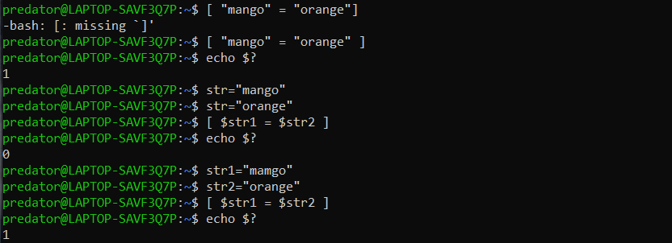

1. **String Comparisons:**



1. **If..elif..else..fi:**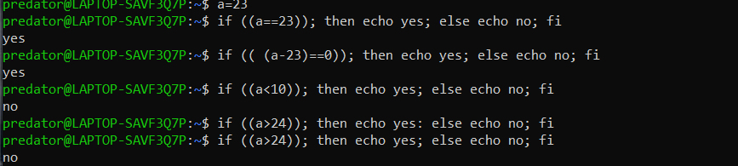
2. **Bash Arithmetic:**
3. **Expr command:**

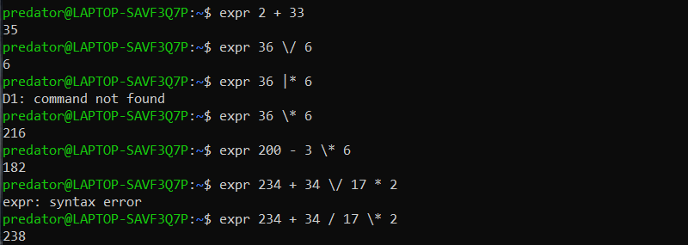

1. **Let command:**

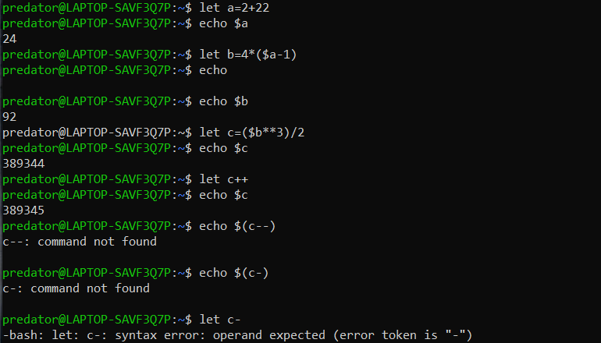

1. **bc command:**

